Online Access Student Information System

TITLE PAGE

An IT Project Proposal Presented To
the Faculty of IT/CS Department
College of Information and Computing Sciences
Saint Louis University
Baguio City

In Partial Fulfilment
of the Requirements for the Course
IT 411 – IT Project 1

by
Aguas, Jesus Anthony A.
Buenavista, Anton Yoel D.
Clemente, Richard James C.
Espelita, Jonah Jose S.
Fabia, Noreen Danielle S.
Go, Franklin Anthony M.
Mendoza, Kasima Rose M.
Saringan, BJ A.

February 2009

TABLE OF CONTENTS

TITLE PAGE i
TABLE OF CONTENTS ii
TABLE OF FIGURES iv
TABLE OF TABLES v
PROJECT ABSTRACT 1
I. Project Name: 1
II. Project Description 1
III. The OASIS Website Staff 3
IV. The OASIS Sections 5
OASIS Home Page 5
Registration Page 5
Help Facility 6
User Main Page 6
Ward’s Profile 6
Attendance. 7
Fees……………………………………………………………………………………………………………………………..…7
Grades 8
Guidance 8
Violations 8
OASIS Administrator Page 9
General Administrator Page 10
FLOW OF OPERATIONS 11
I. Business Rules 11
Web Services 11
Web Content Policies 12
User Access to the SIS Website 12
Staff Access to the SIS Website 13
Start/Closing of the School Year 13
II. System Operation Sequence 14
REQUIREMENTS DEFINITION 15
I. Functional Requirements 15
For Users 15
For OASIS Website Staff 18
II. Stakeholders 20
III. End-users 20
IV. Hardware and Software Requirements 21
V. Quality of Service Requirements 23
DESIGN 25
I. System Architecture 25
II. Site Map 25
III. Data Design 25
IV. User Interaction 25
INTERFACES 28
Appendix A Glossary 32
Appendix B OASIS Terms and Conditions 35
Appendix C OASIS Privacy Policy 39
Appendix D Frequently Asked Questions (FAQ’s) 42

TABLE OF FIGURES

Figure 1 The OASIS Organizational Structure 3
Figure 2 Current SLU System Operations Sequence 14
Figure 3 View Administrators User Interaction Diagram 25
Figure 4 Add New Administrator User Interaction Diagram 26
Figure 5 View System Logs User Interaction Diagram 26
Figure 6 Edit Administrator User Interaction Diagram 27
Figure 7 OASIS Homepage 28
Figure 8 First Step of Registration Page 29
Figure 9 Second Step of Registration Page 30
Figure 10 Confirmation of Registration 31

TABLE OF TABLES

Table 1 OASIS Server Hardware Requirements 21
Table 2 Server-side Software Requirements 22
Table 3 OASIS Client-side Hardware Requirements 22
Table 4 Client-Side Software Requirements 23

PROJECT ABSTRACT

- Project Name: Online Access Student Information System (OASIS)

Project Description

The Online Access Student Information System (OASIS) is a web-based application that enables parents and guardians (known as users henceforth) to view school information which pertains to their student of concern (known as wards henceforth) who is studying in Saint Louis University. All relevant student information shown in the application is retrieved from the Management Information Systems (MIS) Office. The users can view the ward’s school information through the OASIS anytime, anywhere as long as the users have access to the Internet. To ensure the security of the ward’s school information, the proposed system will require logging in by means of a username and password for the users to view their own ward/s' information.

Although the OASIS’ main purpose is to cater to the needs of parents and guardians, interested students may also make use of the system to view their own information. The OASIS will only cover undergraduate and post-graduate courses of Saint Louis University. Pre-school, elementary and high school students will not be covered by the proposed system.

The OASIS includes the following features:

- User Accounts – The system will provide facilities for easy creation, storage, disabling, and maintenance of user accounts. Only the OASIS Administrator is authorized to maintain, enable and disable user accounts. However, users may also change some preferences in their own accounts. This may be done in the account settings feature provided once the user has logged in.
  - User Information – The system will use this information as a reference for the creation of account for the system. This information includes the user’s name, nickname, address, e-mail address and mobile number.
  - Language Preference – The user may choose to view their OASIS accounts in either the default English language or the Filipino language.
  - Ward Re-ordering – For those users who have multiple wards, they may choose their main ward or the topmost ward from the list of wards that they already have.

- Ward Information – As the main access for the system, ward information is the most important data retrieved and shown to the users. The user can view relevant information regarding their ward/s.

- Notifications – The system allows the user to be notified regarding changes in their ward's related information. For a list of possible notifications, please refer to Appendix G.

- Important Announcements – The system allows everyone to view important announcements regarding both Saint Louis University and OASIS. These announcements include campus activities and site announcements.

- Help Facility – The system provides a facility for the users to ask for assistance with the use of the OASIS. A page for the Frequently Asked Questions (FAQ’s) and a query box will be provided in the OASIS website.

- Administration Facility - The system provides facilities for administrators to manage the OASIS.

The OASIS Website Staff

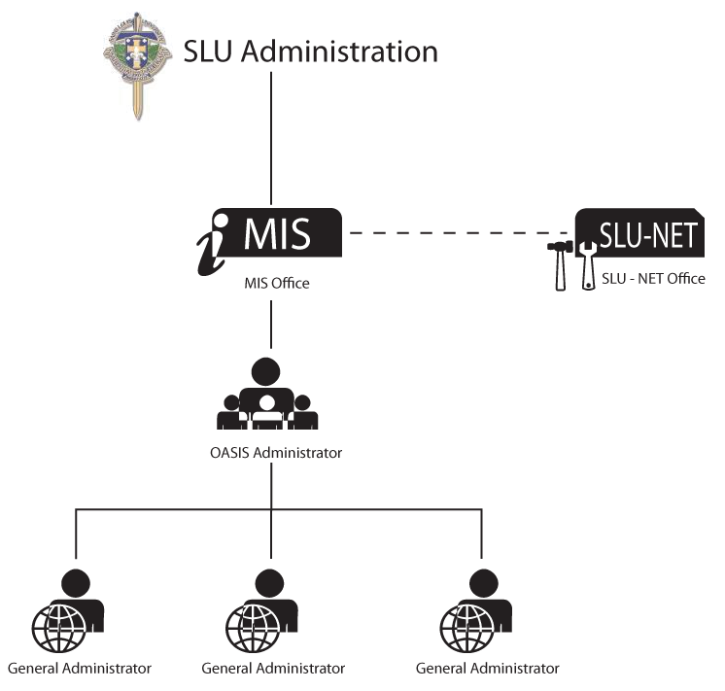
Figure 1 The OASIS Organizational Structure

Shown above is the OASIS organizational structure in connection with the SLU administration and the Management of Information Systems (MIS) Office and the SLU-NET Office. Decisions within OASIS are still affected by the decisions of the SLU administration and the MIS Office itself. The SLU-NET Office will work hand-in-hand with the MIS Office in OASIS’ hardware and networking set-up and maintenance. The OASIS organizational structure is adapted from the MIS Office’s organizational structure; in addition, its members are also employees of the MIS Office.

- OASIS Administrator (OA)
- Creation of Account: The OA’s account is created by default and is hard-coded in the OASIS on OASIS’ first deployment. There can only be one active account for the OA, thus, there can only be one OA at a time.
- Responsibilities: The OA will be in charge of the overall administration of the OASIS. Responsibilities will include the addition of lower administrators, overseeing of activities done by the other administrators.
- Access Privileges: OA has complete access to all functions of the OASIS which fully includes user accounts and also has the ability to create administrator accounts.
- Qualifications: The basic qualifications of an OA are that he or she must be a graduate of Bachelor of Science in Computer Science, Information Technology or its equivalence. A completed master’s degree is optional, but favoured. The OA must already have administrative and supervisory experience in dealing with web services. The OA is preferably one who possesses comprehensive knowledge on web technologies and database systems.

- General Administrators (GA)
- Creation of Account: The GA’s account is created by the OASIS Administrator. A GA’s account may only be deactivated by the OA. Furthermore, there can only be three active accounts for the GA, thus, there can only be three active GA’s at a time.
- Responsibilities: The GA will be assisting the OA in the overall administration of the OASIS. The GA will be responsible for the tasks assigned to him by the OA. However, the GA does not have any privilege of adding, activating and deactivating user and administrator accounts alike.
- Access Privileges: The GA has just about the same access privileges as the OA with the exception of accounts management.
- Qualifications: The basic qualifications of an OA are that he or she must be a graduate of Bachelor of Science in Computer Science, Information Technology or its equivalence.

The OASIS Sections

OASIS Home Page
  - Login Box – Consists of a username textbox, a password textbox and a button that directs a successful user login to the user’s main page. A “Forgot password” link that directs to the password reset page is provided. In addition, a “Remember Me” checkbox is also provided that if checked, keeps the account logged in for two weeks.
  - Registration Link and Instructions – Gives the user a three-step instruction on how to register and directs the user to the registration page of the OASIS website.
  - OASIS Description – An overview description on what the OASIS website is, its functionalities and how the user may be able to use these.
  - Announcements Section – A list that displays the academic and non-academic activities and holidays that affect Saint Louis University’s schedule of work and classes.

Registration Page
  - Student Verification Code (SVC) and ID Number Entry Page – The first form that is to be seen during the visitor’s registration wherein one enters the ID number of the student of concern. After which, the correct SVC indicated on the Verification SMS Message must be entered for validation purposes. On the same page, a Captcha test will be needed to be completed by the registering visitor in order to proceed to the next step.
  - Registration Form – Another step in the registration process wherein the applicant enters personal information, such as first name, middle name, last name, nickname, address, and e-mail address, as well as login information such as username and password.
  - Terms and Conditions and Privacy Policies – A list of bylaws and explanation of rights, obligations and rules being upheld by the OASIS that the user must agree upon to be finally approved use of the OASIS’ facilities. (Please refer to Appendix B for the Terms and Conditions and Appendix C for the Privacy Policy.)
  - Confirmation of Registration – This page will be displayed if the registration is successful. After which, a confirmation SMS message of one’s registration will be sent to the user’s mobile number.

Help Facility
  - Frequently Asked Questions – These are information regarding the most common concerns that a user may have regarding the OASIS. For the OASIS Website’s FAQ’s, please refer to Appendix D.
  - Query Box – A facility where the user may enter any questions, comments, concerns or suggestions to be read by the OASIS Website Staff. Responses to these queries will be received via e-mails.

User Main Page
  - List of Wards – Seen as soon as the user has successfully logged into the OASIS. This consists of a list of all the wards the user is following.
  - Notification Box – A small box on the lower right corner of the user’s main OASIS page that displays short messages regarding the changes in the scholarly information of a specific ward.
  - Add New Ward – A link that directs the user to a page where the user may add a ward to be followed.

Ward’s Profile
  - Ward Information – Personal information regarding the ward of concern which contains the photo of the ward uploaded by the user, ID number, full name, mother’s name, father’s name, guardian’s name, the relationship of the guardian to the ward, course and year level, college, ward's status.
  - Current Class Schedule – The ward’s class schedule for the currently enrolled term containing the course number, descriptive title, units, room, time and day of the subjects.
    - There are some subjects that will not contain time, room and day such as practicum, on-the-job training and field trip classes.

Attendance – The attendance tab displays only the subjects that fall under any of those in the Attendance Status of the student’s subject. These are class cards that are dropped to the Student Affairs Office due to accumulated absences. The following can be seen in this tab.
  - Course Number of the subject
  - Class Code – This is the respective subject’s class code for the dropped class card.
  - Number of Absences
  - Attendance Status – May be Dropped (D), Withdrawal with Permission (WP) or Totally Dropped (TD)
  - As of Date – This is the date of when the attendance status has become applicable to the subject of concern.

Fees – The fees for the whole semester excluding those that are not presented in the original schedule of fees at the start of the semester such as, yearbook, graduation and breakage fees.
  - Breakdown of Fees – The detailed information regarding the fees that are to be paid. This usually includes tuition fees per unit, entrance fee for freshmen and miscellaneous fees. Previous payments made are also included here as a deduction to the total fees to be paid.
  - Current Balance – The current outstanding balance of fees from the previous payment transaction.
  - Assessment of Fees – The information regarding the fees needed to be paid for the term.

- Grades – The final grades per semester.
  - Course and Year – This is the course and year level of the ward during the semester when the subjects of concern were being taken.
  - Course Number of the subject
  - Descriptive Title of the subject
  - Units – Number of units for the subject. If the number of units is enclosed within parentheses, then this means that the subject is a required, non-academic subject.
  - Grade – Final grade for the subject or status such as withdrawn with permission (WP), and dropped (D), and not credited (NC).
  - Remarks – Comments, if any, regarding the subject such as incomplete (INC) or no final examination (NFE).
  - Percent passed – Ratio of subjects passed for the semester.
  - History of Grades – An archive of previously obtained grades per semester in a curriculum since first time of enrolment from Saint Louis University.

- Guidance – These are records of the ward’s counseling sessions in the Saint Louis University Guidance Center.
  - Date when the counseling occurred
  - Time when the counseling occurred
  - Room of the guidance session.
  - Counseling notes and remarks

- Violations – These are misconducts reported at the Student Affairs Office. Only violations that were reported to the Student Affairs Office may be displayed in the OASIS.
  - Date of when the violation was reported
  - Description of the ward’s offense
  - Memo Details – These are displayed as the punishment given to the ward for a particular. Below is a list of possible penalties that a ward may receive, based on the 2004 Saint Louis University Student Handbook.
    - Warning
    - Reprimand
    - Censure
    - Suspension
    - Non-readmission
      - Dropping/Dismissal
      - Expulsion
    - Other Sanctions

- Account Settings – Facilities are provided that allows the user to change or modify some of the information regarding the account. The user may change the nickname, password and e-mail address, but not the username. Other settings are as follows:
  - Language Preference – Allows the user to choose whether to view the OASIS in English or Filipino (otherwise known as Tagalog).
  - Notification Preferences – Allows the user to choose whether to receive notifications or not, and whether to receive these notifications via e-mail or SMS.

- Administrator Login Page – For security purposes, a login screen for the administrative staff of the OASIS which will be placed on a separate domain from the user’s log-in page will be provided. This contains the username and password textboxes and a login button.

- OASIS Administrator Page – The OA’s page has all the facilities needed by the OA for the overall management and manipulation of the OASIS.
  - Administrator Management – This is a facility for adding, editing, viewing General Administrator Account details such as the name, username, access level, e-mail and last visit. This also enables the OASIS Administrator to enable and disable General Administrators.
  - System Reports – A facility for viewing reports such as user visits per day, online administrators, and the record statistics such as number of registered users, number of student records, number of new student records, last update of records, number of currently online users, date when most online users has logged in, student records, user accounts, and number of blocked accounts.
  - View Actions Log – A facility for viewing transactions of activities of the OASIS staff members. A filter mechanism is provided in order for action logs to be viewed according to date, action made and administrator who issued the action.
  - Announcements – A facility for adding in and editing announcements is provided for important notices and announcements that are addressed to the general viewers of the site.
  - User Queries – On this page, the administrator may view user queries that were sent in through the Query box in the user page. The administrator may also reply to these queries through the accessing computer’s local mail client. Sorting and filter mechanisms are provided for easy management of queries.
  - Change Password Page – A page wherein the administrator may change his password.

- General Administrator Page – The GA’s page has just about all the facilities of that the OA may use except for the administrator management facilities.

FLOW OF OPERATIONS

Business Rules
The Online Access Student Information System provides business rules in order to facilitate and maintain the use of the site.

Web Services

Initial ward information is retrieved from the Management Information System Office. This information are retrieved through the web services the evening after the last day of enrolment for the term. The information gathered during this period will be used for sending the Verification SMS Message to the parents. Generation and sending out of Verification SMS Messages will start on the day after initial ward information has been gathered.
Wards’ information that is to be retrieved is as follows:
  - Ward Information – Ward’s personal information such as ward’s perpetual identification card (ID), ID number, full name, mother’s name, father’s name, guardian’s name, course and year, college ward's enrolment status, relationship to the guardian, mobile number and email address, if any.
- Schedule – Ward’s class schedule during the present term, which includes the course number, descriptive title, unit, time and days, and classroom where the course is being held.
- Grades – The ward’s grades per semester. Wards’ grades are only available one day before enrolment period and updated a month after.
- Attendance – Ward’s attendance which includes absences and dropped subjects. The basis on how class cards are dropped depends on the number of units assigned to the subject.
- Violations – Ward’s violations and corresponding notes recorded by the Student Affairs Office.
- Ward’s Status – Ward’s enrolment status as of a certain date during and after the enrolment period. Below is a list of a ward’s possible enrolment statuses.
      - Enrolled – A status type that will be shown when the ward was able to enroll before the end of the enrolment period.
      - Not enrolled – A status type that will be shown when the ward has failed to enroll before the enrolment period ends.
- Course Offerings – This is a publicly-available page that displays all the courses being offered by the different colleges of the university at a certain term and school year.
The OASIS also acquires data from the users of the website. These are total hits of the site and log in and log out times of users.

Web Content Policies

These are stipulations that contain details on the proper use and responsibilities while in the OASIS domain. The responsibilities of the user to the OASIS are not the only ones mentioned here, but the responsibilities of the OASIS to its users as well. The OASIS Web Content Policies comprises of the following:

  - Terms and Conditions; and
  - Privacy Policies

User Access to the SIS Website

  - Public Viewer – Includes the students, SLU faculty members, and the general public.
    - Can only view the home page (not logged in page) of the website
    - Can register as long as there is a valid ID number and a matching Student Verification Code (SVC)
    - Can view site announcements
    - Can view the website information pages such as, Terms and Conditions, Privacy Policies, Frequently Asked Questions, and About the OASIS page

  - Users – These are the registered followers of a ward.
    - Have all the privileges of a public viewer
    - Can add a ward to follow if the correct SVC is provided
    - Can view wards’ profiles and related information
    - Can upload wards’ pictures
    - Can edit user account details
    - Can report problems regarding the use of the site through the query box

Staff Access to the SIS Website

- OASIS Administrator
    - Can view, add, edit, activate and deactivate general administrators
    - Can view, activate and deactivate users
    - Can view reports about the website and actions log of administrators
    - Can post and edit announcements
    - Can review and reply to user queries
    - Can compose, edit and send out e-mail notifications to users
    - Can turn website status on or off

- General Administrator
    - Has the privileges of an OASIS administrator except administrator management

Start/Closing of the School Year

System Operation Sequence
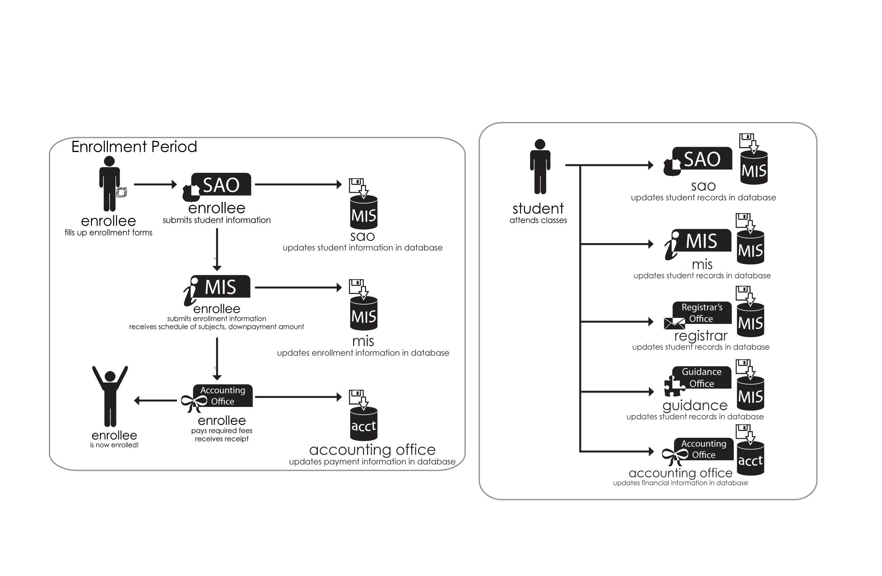
Figure 2 Current SLU System Operations Sequence

REQUIREMENTS DEFINITION

Functional Requirements

For Users
  - User Registration
Summary: This function allows users to register to the OASIS by following a sequence of registration steps in order to avail of its services.
Rationale: User registration is needed to verify users that will be using the OASIS since possible sensitive information will be shown to its users.

  - Login Management
Summary: This function allows users to securely log into the OASIS by typing the user’s login username and password in order to avail its services. It also assists users to recover their forgotten password and/or username by clicking the “Forgot password” link in the login box.
Rationale: Login Management allows users to securely login and view information relevant only to them.

  - User Account Management
Summary: This function allows users to set and store account settings such as e-mail and SMS notifications, nickname, address, password and email address changing.
Rationale: Settings management is useful since different users will have different preferences for the use of their OASIS accounts when the need arises.

  - User’s Ward Validation
Summary: This function allows users to identify the student they wish to follow and to validate whether or not the ward is related in any way to the user by entering a Student Verification Code that has been sent to the user.
Rationale: This function provides a secure method of validating whether the user can view this particular student’s information. It protects both the user and the ward.

  - Viewing of Ward Profile
Summary: This function allows the user to view personal information of the ward, such as the full name, home address and others.
Rationale: The information provided will allow the user to view details needed for other deeds, to act as a reminder for forgotten information, or to use the information in order to contact the ward.

  - Viewing of Ward Schedules
Summary: This function allows the user to view the class schedule for each subject of the ward.
Rationale: The information provided will inform the user about the ward’s class schedules.

  - Viewing of Ward Attendance
Summary: This function allows the user to view the class card attendance of the student, such as the recorded absences, if the class card has been claimed or dropped.
Rationale: Information regarding the attendance of the ward is relevant to the user that oversees the ward.

  - Viewing of Ward Grades
Summary: This function allows the user to view all grades for each subject of the ward.
Rationale: Information regarding the grades is among the primary interests of a user in wanting to view a ward’s scholastic information.

  - Viewing of Ward Accounting Information
Summary: This function allows the user to view all relevant accounting information, such as balances, assessments, breakdown of fees and other fees.
Rationale: Accounting information regarding the student allows the user to prepare money beforehand or assess the current payments made to Saint Louis University.

  - Viewing of Ward Violations and Guidance Details
Summary: This function allows the user to view information about the violations committed by the ward and guidance counseling sessions, if any.
Rationale: Information regarding ward violations is needed by the user in order to assess the ward and take appropriate disciplinary actions.

  - Viewing of Enrolment Status
Summary: This function enables the user to view the enrolment status of the ward such as when the ward is enrolled or not enrolled.
Rationale: This function informs the user the current enrolment status of the ward.

  - Viewing of Other Ward Followers
Summary: This function enables the user to view other users that have been following the ward.
Rationale: This function enables the user to be aware of other verified users that are viewing the ward’s information and to identify any fraudulent users that may take advantage of the information being shown.

  - User Support
Summary: This function allows users to contact the administrators of the OASIS via a query box then sent to the administrators’ query viewing and response facilities.
Rationale: User Support is needed since special cases may arise from the usage of the services of the OASIS. User Support enables the user to easily contact and ask for any assistance in the event the user does not know what to do. There is also a Frequently Asked Questions section in the OASIS where the solutions for common problems are found.

- Password Resetting
Summary: This function allows users to reset their passwords securely in case that they have forgotten it.
Rationale: The facility to reset passwords of users is important because it will be inevitable that one may forget one’s password.

For OASIS Website Staff
- Administrator Login Management
Summary: This function enables administrators to login to their respective administrator panels in order to perform actions on the OASIS.
Rationale: Administrators need to specifically login into the OASIS administrator domain in order to perform their respective functions.

- User Account Administration
Summary: This function enables the Oasis Administrator to administer user accounts, such as the block, unblock, or reset the account of the user.
Rationale: This function is needed since special cases may arise such as the abuse of the user’s account.

- Administrator Logging Transactions
Summary: This function transacts all actions done by administrators in a session. Each action done is logged with a timestamp and the description of the action.
Rationale: This function is needed in order to have a trace in case something goes wrong especially since administrator functions are very powerful actions.

- Administrator Account Management
Summary: This function is solely for the OASIS Administrator wherein he is enabled to create administrator accounts.
Rationale: This function is especially needed by the OASIS Administrator in order to distinguishingly assign responsibilities to OASIS Website Staff members and distribute their functions respectively.

- Account Settings Management
Summary: This function allows administrators to set and store account settings such as e-mail address and password changes.
Rationale: Account settings management is needed for the security and flexibility of the administrators’ accounts.

Stakeholders

- Parents and Guardians
- Students
- Faculty members and staff members of the Dean’s Offices of all Colleges
- The OASIS Website Staff
- Specific Departments of Saint Louis University, namely:
- Management of Information Systems (MIS) Office
- SLU-NET Office
- Student Affairs Office (SAO)
- Guidance Office
- Registrar’s Office
- Accounting Office

End-users

  - Parents and Guardians of Saint Louis University students
  - Parents and guardians can access all available features of the website pertaining to their ward/s provided that they are registered users of the OASIS.

  - Saint Louis University Students
      - The students of Saint Louis University may also make use of the services provided by the OASIS for as long as they have a valid ID number and its corresponding Student Verification Code.

  - OASIS Website Staff
  - The staff may access the back-end controls of the OASIS.
  - The staff may also access all available features of the website if and only if their ward/s is currently enrolled and have registered their OASIS accounts upon enrolment.

Hardware and Software Requirements

Listed below are the minimum and recommended software and hardware requirements for the OASIS’ server. Hardware requirements may exceed the recommended requirements, if desired.

SERVER SIDE HARDWARE REQUIREMENTS (Minimum)
Processor | Intel® Core™ 2 Duo, 2.0GHz, HT, 2MB Cache
Hard Disk | 160 GB Hard Drive (10Krpm)
Motherboard | Intel LGA 775 DDR2 ATX
Memory | 2GB DDR2 Memory
Display | Resolution 1024x768
Keyboard | QWERTY Keyboard
Mouse | Mechanical Mouse
Back-up Power Supply | Uninterruptible Power Supply with the capacity of 1000VA
SERVER SIDE HARDWARE REQUIREMENTS (Recommended)
Processor | Intel® Core™ 2 Quad Extreme Processor (3.00GHz; 12MB L2 Cache; 1600MHz Front Side Bus)
Hard Disk | At Least 1 TB SATA Hard Disk or 60GB Free Space  At Least 512 GB SATA Hard Disk (for back up)
Motherboard | Intel® Desktop Board D5400XS
Memory | At Least 8GB DDR2 Memory
Display | Resolution 1024x768
Keyboard | QWERTY Keyboard
Mouse | Optical Mouse with Wheel
Back-up Power Supply | Uninterruptible Power Supply with the capacity of more than 200VA
Other Specifications and Notes | CD R-RW with DVD R

Table 1 OASIS Server Hardware Requirements

For a short definition of the software shown below, please refer to the Glossary in Appendix A.

Server Side Software Requirements
Operating System | Ubuntu Server 8.10
Framework | Ruby on Rails v2.2
Database Management System | PostgreSQL v8.3.5
Web Server | Thin Webserver v1.0.0

Table 2 Server-side Software Requirements

Listed below are the minimum and recommended hardware and software requirements for OASIS’ viewers. . Hardware specifications may not be lower than the set minimum requirements; however, it may be higher than the set recommended requirements.
CLIENT SIDE HARDWARE REQUIREMENTS (Minimum)
Processor | Intel or AMD processor with 900MHz speed
Hard Disk | At least 50MB free space
Memory | 64MB RAM
Display | Resolution 1024x768
Keyboard | QWERTY Keyboard
Mouse | Mechanical mouse
Internet Speed | 56 kbps connection
CLIENT SIDE HARDWARE REQUIREMENTS (Recommended)
Processor | Intel Pentium 4, 2.8GHz
Hard Disk | At least 1GB free space
Memory | 512MB RAM
Display | Resolution 1280x1024
Keyboard | QWERTY Keyboard
Mouse | Optical Mouse
Internet Speed | 128 kbps connection or higher

Table 3 OASIS Client-side Hardware Requirements

In the table below, a list of recommended browsers in which the OASIS can be best viewed in is shown. Alongside with these browsers are the operating systems wherein these browsers can be installed and run.
Client Side Software Requirements
Operating System | Browser
Windows 98 or later | Mozilla Firefox 2.0 or later  Google Chrome (Windows XP SP 2 or later)  Opera 9.5 or later
Any Linux OS Distribution | Mozilla Firefox 2.0 or later  Opera 9.5 or later  Swiftweasel 2.0.0.5 or later

Table 4 Client-Side Software Requirements

Quality of Service Requirements

Reliability
- Service should be available 24 hours every day unless there is server maintenance or updates.
- The system should be recoverable to a stable state within four hours of downtime.

Promptness
- The loading of website pages must be promptly displayed when requested at all times.

Confidentiality
- Ward information viewing is limited to followers of the said ward to whom they are linked to and with authorized logins.
- User information will be kept confidential and will be used only for user validation purposes; however, the information will be surrendered if requested by the authorities.

Accuracy
- The system should be accurate regarding all transactions, computations, and display of data.
- All ward information retrieved from the MIS and Accounting Office is considered accurate.

Ease of Use
- Navigation is available as a menu at the top of the page
- The system provides a simple interface of which an internet novice would not have trouble understanding and navigating.
- A help facility will be provided for users requiring assistance on using the site.

Security
- Passwords and SVCs are encrypted using a 256-bit SHA2 digestion algorithm accompanied with a unique salt.
- Log-ins of users are authenticated through session-based authentication. Aside from this, after five (5) times of unsuccessfully logging in, a Captcha test will be done in order to ensure that scripts are not being used for logging into the OASIS.
- Before a visitor can successfully register, a Captcha test is performed in order to make sure that the visitor is a human and not a script or program that is designed to automatically make accounts on a website.
- Transactions are used to ensure the security of a logged in user. If a user’s page becomes idle for more than fifteen (15) minutes, then the user is automatically logged out. A user would need to login again to the OASIS, if needed.

DESIGN

System Architecture

Site Map

Data Design

User Interaction

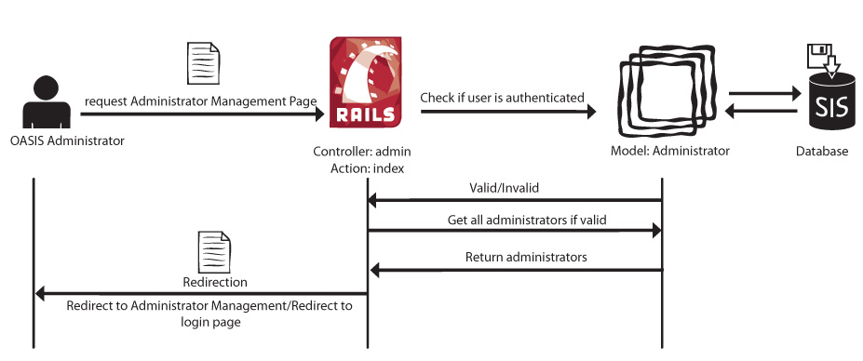
Figure 3 View Administrators User Interaction Diagram

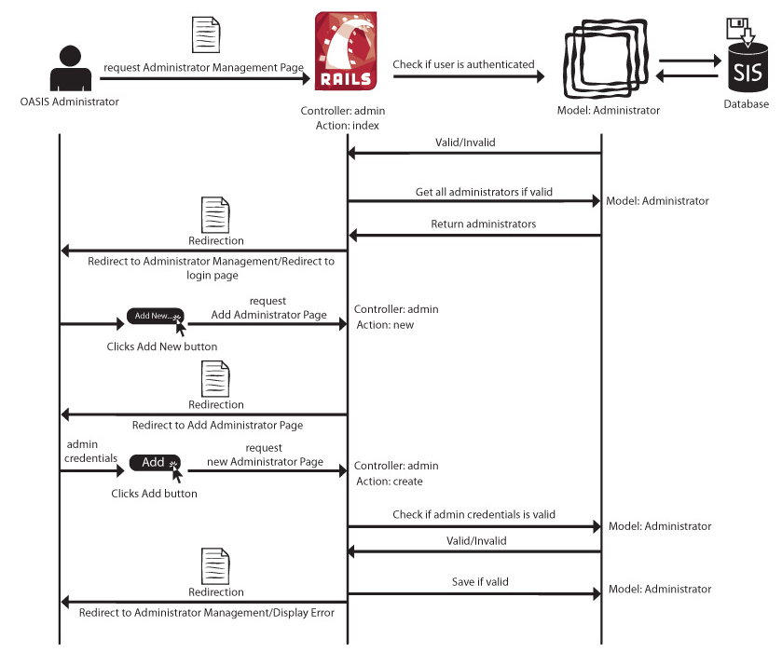
Figure 4 Add New Administrator User Interaction Diagram

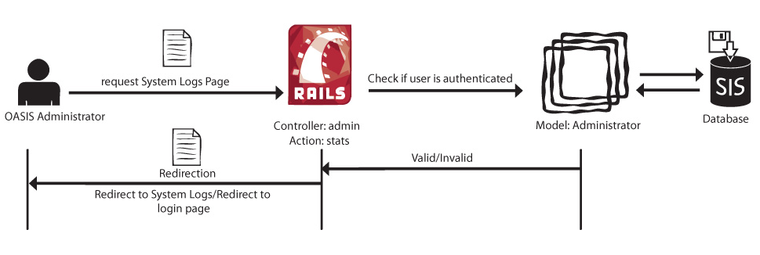
Figure 5 View System Logs User Interaction Diagram

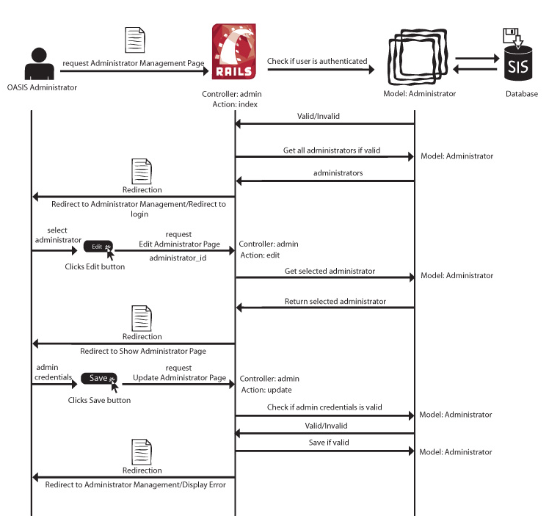
Figure 6 Edit Administrator User Interaction Diagram

INTERFACES

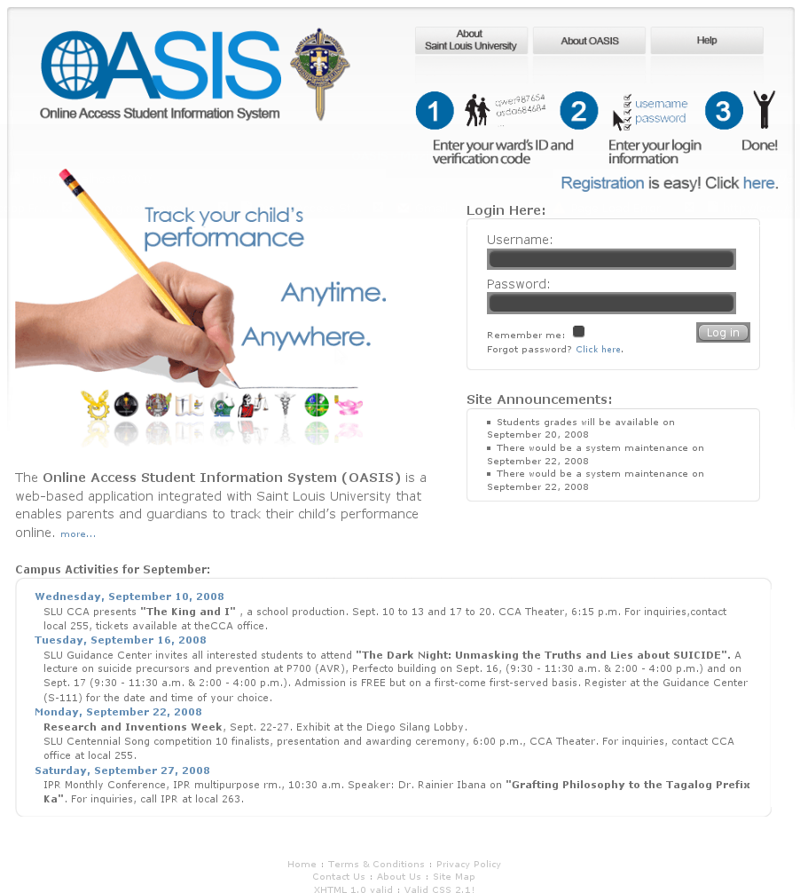
Figure 7 OASIS Homepage

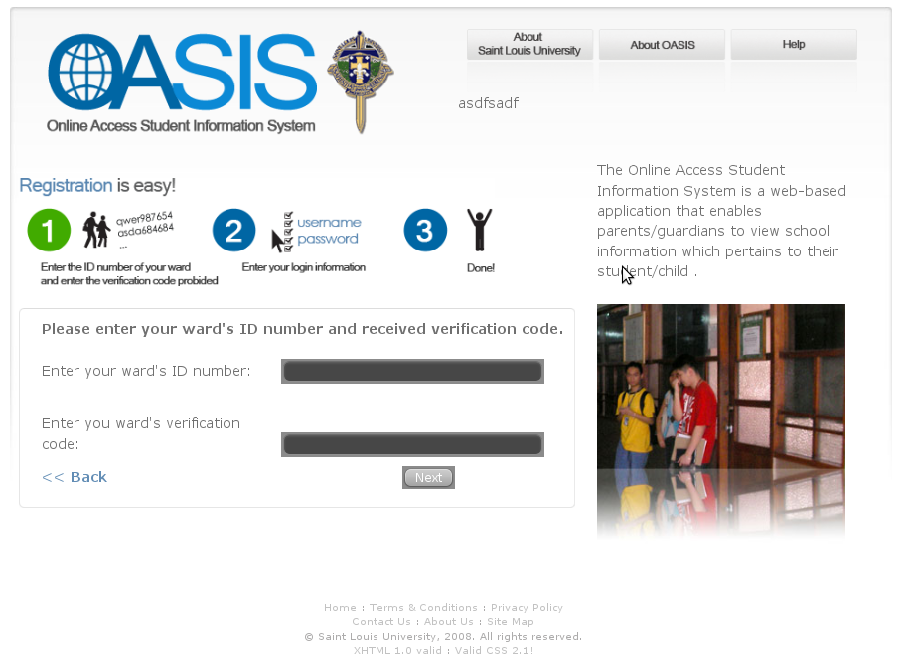
Figure 8 First Step of Registration Page
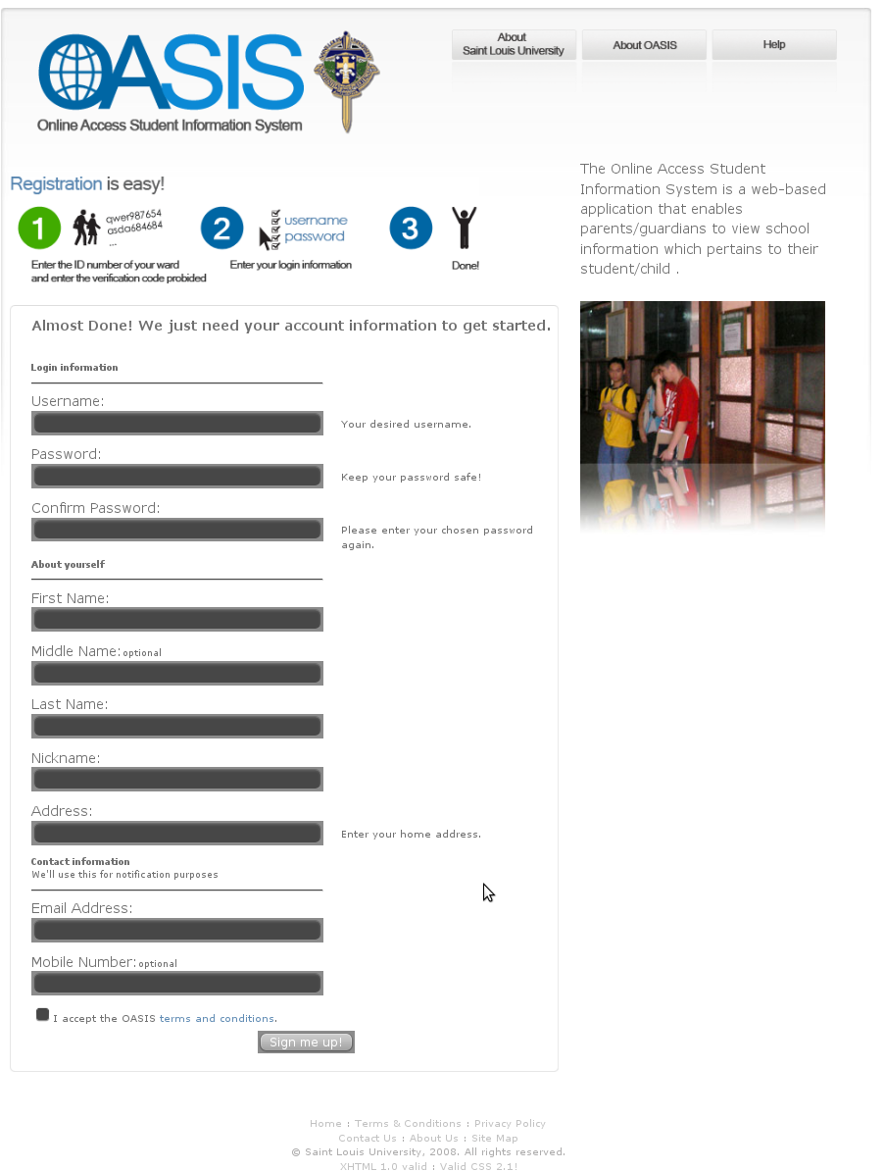
Figure 9 Second Step of Registration Page

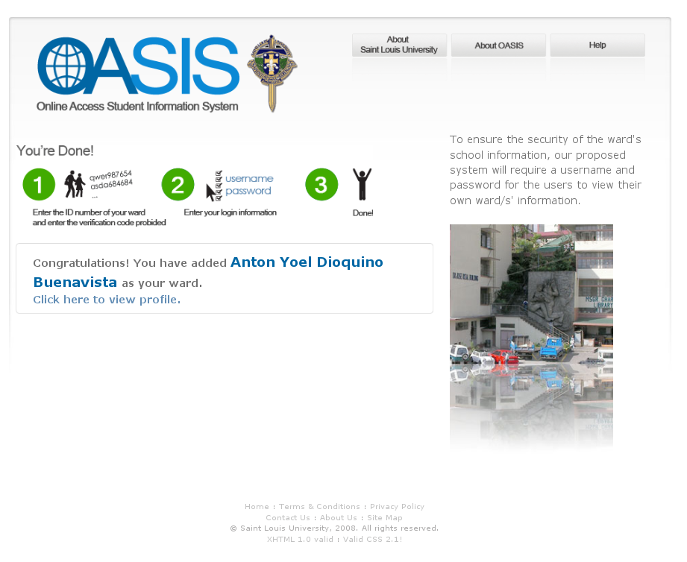
Figure 10 Confirmation of Registration

Appendix A

Glossary

Captcha. Captcha is an image containing an alphanumeric code that can normally only be read and interpreted by a human. This is to prevent computer programs from automatically creating accounts.
Followers. A group of users who have the same particular ward with whom they are keeping track of.
General Administrator (GA). The GA is a person appointed by the Saint Louis University to assist the OASIS Administrator in the administration and maintenance of the OASIS website.
Hypertext Mark-up Language (HTML). HTML is the set of symbols or codes inserted in a file intended for display on a World Wide Web browser page. The mark-up tells the Web browser how to display a Web page's words and images for the user.
Model-View-Controller Architecture (MVC). The MVC Architecture is an architectural pattern used in software engineering. Successful use of the pattern isolates business logic from user interface considerations, resulting in an application where it is easier to modify either the visual appearance of the application or the underlying business rules without affecting the other.
OASIS Administrator (OA). The OA is a person appointed by Saint Louis University to carry out the overall administration and management of the OASIS website.
Online Access Student Information System (OASIS). The OASIS is the web-based application that will help parents and guardians keep track of their Saint Louis University student(s) of concern.
PostgreSQL. PostgreSQL is an object-relational database management system (ORDBMS). It is released under a BSD-style license and is thus free software.
Ruby. Ruby is a dynamic, reflective, general purpose object-oriented programming language that combines syntax inspired by Perl with Smalltalk-like features.
Ruby on Rails (RoR). RoR is an open source web application framework for the Ruby programming language. RoR is pertained to as just Rails by most enthusiasts and developers.
Short Message Sending (SMS). SMS’s are often termed as text messages. These are short messages, one part often consisting of 168 characters or less, that may be received via a mobile phone.
Student Verification Code (SVC). An SVC is a six-digit code generated from hashing the student’s ID number, and it is used to confirm whether a registering visitor is indeed a valid parent or guardian of the ward of concern. This SVC is placed in the SMS message that is to be sent to the parents that will inform them of OASIS.
Thin Webserver. Thin is a Ruby web server that glues together 3 of the best Ruby libraries in web history: the Mongrel parser, the root of Mongrel speed and security; Event Machine, a network I/O library with extremely high scalability, performance and stability; Rack, a minimal interface between webservers and Ruby frameworks.
Ubuntu Server. Ubuntu Server is is a computer operating system based on Debian GNU/Linux, a popular Linux distribution. It is built on the solid foundation of Debian which is known for its robust server installations.
User. A user is a registered and approved parent or guardian in the Online Access Student Information System (OASIS).
Verification SMS Message (VSM). An SMS message that is sent to the ward’s followers that contains the ward’s information (name, ID number and SVC), information on the OASIS website and instructions on how to register.
Visitor. The visitor is a viewer who is not logged into OASIS. A visitor may not see information regarding the wards.
Ward. A ward is a college student of Saint Louis University who is under the protection or in the custody of the parent or guardian.
Ward Information. The student information is a collection of facts with regards to a certain subject.
Web Browser. A web browser is a software application that is used to locate and display web pages.
Web Services. Web Services is a software system designed to support interoperable machine-to machine interaction over a network

Appendix B

OASIS Terms and Conditions

Shown below are the Online Access Student Information System Terms and Conditions.

ACCEPTANCE OF TERMS
Online Access Student Information System (OASIS) is intended for the parents and guardians of SLU Students. By accessing and using the OASIS system, you accept and agree to be bound by these Terms of Service (referred to as this Agreement henceforth).

This Agreement sets out the legally binding terms of one's use of the OASIS website whether one is a visitor (non-registered viewer) or a user (registered parent or guardian). One is only authorized to use the OASIS' services (regardless of whether the access or use is intended) if one agrees to abide by all applicable laws and the terms of this Agreement. If one does not agree to be bound by this Agreement and to follow all applicable laws, one should leave the OASIS website and discontinue use of the OASIS services immediately.

OASIS may modify this Agreement from time to time and such modification shall be effective upon posting by OASIS Admin on the OASIS Website. One's continued use of the OASIS’ Services after OASIS posts a revised Agreement signifies one’s acceptance of the revised Agreement. It is therefore important for one to review this Agreement regularly to ensure one is updated as to any changes.

OASIS is operated by the OASIS Website Staff of Saint Louis University. The services of OASIS are offered to parents and guardians who wish to monitor their ward's academic performance. It is also available for students who would like to monitor their own performance. In order to monitor or “follow” your ward’s academic performance, you must have a Student Verification Code sent by the OASIS Website Staff of Saint Louis University.

SERVICES OFFERED
OASIS’ services are for registered parents or guardians, also known as users or followers. A visitor can only view the main page of the website.

Through OASIS, a parent or guardian can monitor a ward’s (academic) information online.

A follower:
- can view a Ward’s profile, grades, checklist, and schedule;
- will be notified of dropped class cards, shifting, checklist updates, grade updates, and violations; and
- can monitor a ward’s accounting fees, breakdown of fees and payments.
The above information is taken from the office of Management Information Systems.

A follower agrees that the provided information is displayed in the user’s pages is for viewing purposes only. OASIS does not accept any liability to any person for the direct, indirect, incidental, special or consequential damages that result from the use or misuse of these provided information.

If the information on the Saint Louis University’s official printed documents differs from the information contained on the OASIS, the information on the University’s official printed documents will take precedence.

REGISTRATION
A ward is required for one to successfully register a user. To monitor a ward, a parent or guardian must know their ward’s Student Verification Code (SVC). SVCs are generated by OASIS for every enrolled student who does not have any followers yet. The only way to obtain an SVC is through the Verification SMS Message (VSM). The VSM is an invitation to parents or guardians for OASIS registration. A VSM contains the ward’s information (name, ID number and SVC), registration instructions and registration period. VSMs are sent to the parent or guardian’s mobile number or requested directly from the OASIS Office in case of lost SVC.

For parents or guardians of SLU students who did not receive a VSM or their VSM’s content has incomplete information, they may contact the MIS Office. A user can have more than one ward. Therefore the number of VSM sent to the mobile number depends upon the number of newly activated wards with that same mobile number.

The OASIS Website Staff and SLU do not require parents and guardians of SLU Students to register in the OASIS. The OASIS Verification SMS Message is merely an invitation.

Security of the VSM’s content will no longer be the responsibility of the OASIS Admin after it has been sent to the parent or guardian’s mobile number.

A ward can have more than one follower; therefore, a parent or guardian is responsible for any registration using the ward’s SVC. The OASIS Administrator or General Administrator can block a user with/without a user’s prior knowledge or consent.

OASIS registration is open online 24/7, except during maintenance and upgrade schedules.

LINKS
OASIS contains hyperlinks to SLU-related sites such as the SLU Official Website, MySLU Portal and SLU Intramurals Site only. Use of the hyperlinks and access to such linked websites are entirely the user's voluntary choice and responsibility. When the user clicks on these hyperlinks to SLU-related sites, it is understood that the user has left OASIS and is now subject to the Terms & Conditions and Privacy Policy of the new site and the information collected or used on these sites.

Other websites may link to OASIS with prior acknowledgment and approval from the OASIS Administrator and SLU. The OASIS Website Staff and SLU must be explicitly identified and duly credited as the source of information displayed. Furthermore, the contents of the website must be presented in the host site without any alterations.

SECURITY
If one uses this system, one should understand that all activities may be monitored and recorded. Anyone using this system expressly consents to such monitoring. This serves as a WARNING that if such monitoring reveals possible evidence or information of criminal or suspicious activity, monitoring records may be provided to law enforcement officials without any prior oral or written notice to the suspected user.

LIABILITY
Violation of any of the terms and conditions, misuse and/or abuse of the website or any of its contents, and/or misrepresentation in any form, may subject the user to the corresponding administrative, civil and/or criminal liability under applicable laws.

Appendix C

OASIS Privacy Policy

Shown below is the Online Access Student Information System Privacy Policy.

This policy covers the treatment of OASIS to personal information OASIS collects and receives, as well as academic and personal information of SLU students OASIS shares to its users.
Information Gathering and Disclosure
USERS (REGISTERED PARENTS AND GUARDIANS/FOLLOWERS)

Parents of SLU students are invited to register in OASIS through sending them an OASIS verification SMS message containing a Student Verification Code (SVC). Parents may share the SVC to whom they see fit and allow them to register and be followers of their child.
OASIS collects personal information when one registers to the OASIS. The information asked from the registering visitor will be the user’s full name which comprises of the first name, last name and middle name, postal address and a valid e-mail address.
When one registers, s/he will be known as a follower of a ward. Followers can know how many other followers their ward has. The only information accessible to a follower is the full name of the other followers.
SLU STUDENTS (WARDS)
Saint Louis University is concerned with the privacy of their students regarding their academic and personal information. Through OASIS, parents and guardians can access SLU student's academic and personal information online. SLU entrusts OASIS with the privacy of these retrieved information that OASIS shares to its users. OASIS limits its registered users with only those who can provide a SVC of SLU Student a registering visitor wants to monitor.
When one is already registered (a “follower”), the follower can have access to the ward’s academic and personal information online. Ward’s personal information are name, course and year, college, mother’s name, father’s name, guardian’s name, address, enrolment status, scholarship and number of siblings. Academic information is the ward’s class schedule, attendance, grades, fees, violations and guidance information.
Aside from the security measures OASIS provides, a follower shares responsibility to a ward’s personal and academic information since the access to the ward’s personal and academic information is limited to the ward’s followers.
GENERAL (Visitors and Users)
The number of times that the OASIS website has been visited is the only information that we acquire from the general viewers. We do not provide users or visitors with access to the non-personal information that we have collected and that we maintain about them.
The information we collect is used to improve the content of the OASIS and used to notify users about updates in the OASIS. OASIS discloses information when legally required to do so, at the request of government authorities conducting an investigation, to verify or enforce compliance with the policies governing the OASIS and applicable laws or to protect against misuse or unauthorized use of the OASIS.
Use of Information
From time to time, we may use user information for new, unanticipated uses not previously disclosed in our privacy notice. Users may prevent their information from being used for purposes other than those for which it was originally collected by sending an e-mail to the OASIS e-mail address.
Cookies
With respect to cookies: We use cookies to store users’ preferences, record session information, such as log-in and log-out timestamps, or other information that the visitors and users send.
If a user does not want to receive an e-mail or SMS message from the OASIS regarding updates and notifications in the site, the user may choose to not receive such e-mails or SMS message by turning it off from notification of the Account Settings.
Advertisements
With respect to Ad Servers: we do not partner with or have special relationships with any ad server companies.
Security and Confidentiality
With respect to security: we have appropriate security measures in place in our physical facilities to protect against the loss, misuse or alteration of information that we have collected from you and the information we share to you at our site.
If you feel that this site is not following its stated information policy, you may contact the OASIS staff members.
Privacy Policy Changes
OASIS may update its privacy policy. If our information practices change at some time in the future we will post the policy changes at the OASIS website to notify the users and visitors of these changes and provide them with the ability to opt out of these new uses. If you are concerned about how your information is used, you should check back at the OASIS website periodically.

Our postal address is
OASIS Administrator
Management of Information Systems Office
Saint Louis University
Bonifacio Street, Baguio City
2600 Philippines

We can be reached via e-mail at oasis.slu@gmail.com
or you can reach us by telephone at (+6374) 442-3043

Appendix D

Frequently Asked Questions (FAQ’s)

Q1. Where would a user find the Student Verification Code (SVC) for validating a ward?
A1. The SVC can be found on the verification SMS message which will be sent to a parent or guardian’s mobile number as indicated in the enrolment form that is filled in during the enrolment of the ward.

Q2. A user forgot his username and/or password. How does one retrieve a lost username and/or password?
A2. There is a “Forgot password” link located in the main page below the password textbox. Click the link and follow the instructions indicated.

Q3. How often is the information in the OASIS updated?
A3. Information in the OASIS is updated daily after the term’s enrolment period.

Q4. What must one do if the SMS message containing the SVC is lost or not received?
A4. If this happens, then one will have to directly go to the Saint Louis University campus located at Bonifacio Street, Baguio City and request for a replacement SVC from the OASIS office.

Q5. A user has recently changed my primary e-mail address. How can a user change his currently registered e-mail address in the OASIS?
A5. A user can change his current e-mail address through the Account Settings manager.

Q6. What does a Login Session Expired mean?
A6. Your current session time logged into the website has expired. The expiration time has been set to a maximum time limit to 1 hour and 30 minutes for security purposes.

Q7. A user is getting an immediate session expiration message. What can a user do about this?
A7. More than likely, "cookies" are disabled on the browser. Enable it by clicking Tools on the File menu, then Internet Options. Click Advanced and then enable cookies.

Q8. One of the wards recently changed his home address. Can the user update his ward’s records through the OASIS?
A8. The OASIS does not provide a functionality wherein a user can update any of his ward’s personal records. In order to accomplish the updating of records, you must directly go to the Registrar’s Office during Saint Louis University’s working hours (7:30am – 5:00pm Mondays through Saturdays).

Q9. A user cannot login to the OASIS.
A9. One possibility is that the account is blocked due to violations done against the OASIS’ Terms and Conditions. If this is not the case, please check that the username and password entered is correct.

Q10. A user cannot view his ward’s recent grades and all that is seen are past grades. When will a user be able to view his ward’s recent grades?
A10. Student grades for the most recent semester are only officially available one day before enrolment period and updated after the enrolment period.

Q11. How will a user know the tuition fee balance of his ward? How often is it being updated?
A11. Tuition fee balance is available at the Fees menu link and is updated every day after the enrolment.

Q12. In the attendance page of the OASIS, I don’t see any indication that my ward was present or not.
A12. The OASIS attendance page only shows the number of absences when the class card for the subject has been dropped.

Q13. Can a user delete his account?
A13. No, a user cannot delete his account.

Q14. How does one add a ward?
A14. One would need to be logged in first before you could add a ward. To add a ward, click on the Add New Ward link on the main page of the user’s OASIS account. From the Add New Ward page, the user would need to enter the ward’s ID number and correct SVC. A user would also need to pass a Captcha test.

Q15. Can a user remove a ward?
A15. No, a user may not delete a ward. Only adding of ward(s) is supported by the OASIS.

Q16. Is OASIS for free?
A16. Yes! Every feature and functionality that one can see on OASIS is completely free.

Q17. How does one know who else is following my ward?
A17. On the User Main Page, other users who are following your ward may be seen at the upper left corner.

Q18. Is there a limit to the number of wards one can add?
A18. There is no limit to the number of wards each user can add. As long as a user has the certain ward’s ID number and SVC, addition of a ward will not be a problem.

Q19. How does one sign in to OASIS?
A19. For new users, registration is needed first before signing in. Otherwise, one will only need to enter your username and password in the log-in box that is located at the right portion of the main page.

Q20. Are the SMS notifications being received by users for free?
A20. Yes, the SMS notifications that are being sent through users’ mobile phones are free.

